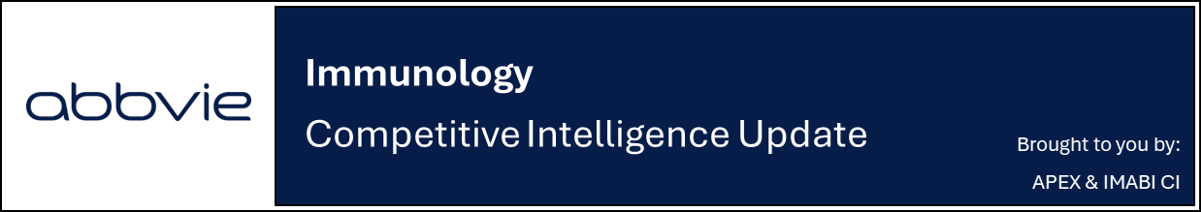

Gazyva delivers strong Phase 3 results in SLE with detailed ALLEGORY readout

Company: Roche  Drug: Gazyva/obinutuzumab (IV CD20 antagonist) | Date: March 9th, 2026  Source(s): Press Release, Presentation,

What happened:
- Roche presented a detailed analysis of the Phase 3 ALLEGORY study evaluating Gazyva (obinutuzumab) + standard of care (SoC) in adults with SLE, demonstrating significant improvements versus placebo across the primary and all key secondary endpoints at week 52 (initial results were announced in Nov 2025, detailed data were presented at SLEuro 2026, in an investor call, and in the NEJM)
- Primary endpoint: 76.7% achieved SRI-4 vs 53.5% with placebo; P<0.0001
- Secondary endpoints:
  - BICLA: 62% vs 40.1%
  - Sustained SRI-4 response: 72.0% vs 46.4%
  - Sustained glucocorticoid reduction: 80.0% vs 54.1%
  - SRI-6 response: 68.9% vs 38.9%
  - DORIS remission: 35.1% vs 13.8%
  - LLDAS: 57.6% vs 25.0%
  - Median time to first BILAG flare: Not estimable vs 52.3 weeks (HR 0.58, P=0.002)
- Safety was consistent with the well-characterized profile of Gazyva, with no new signals reported
  - Infections, infusion-related reactions, and drug-related neutropenia were higher in obinutuzumab-treated patients (68.2%, 11.9%, 4.6%) vs. placebo (54.3%, 3.3%, 2.0%), respectively
  - One death reported in obinutuzumab group due to soft-tissue infection and pneumonia
- Gazyva was messaged (in line with HCP discussions) as a long-term, 1L steroid and flare-reducing SLE therapy with potential to reduce length of IV infusions (similar to LN)
- Regulatory discussions are underway with Q1 2026 US/EU filing confirmed; CI estimates approval in Q4 2026

Impact (CI PoV): HIGH
- Positive Phase 3 ALLEGORY results position Gazyva as a potential new standard of care in SLE, with robust efficacy across multiple clinically relevant endpoints
  - Gazyva was approved for lupus nephritis (LN) in October 2025, making it the second therapy approved for both SLE and LN, besides Benlysta
  - Gazyva’s infrequent IV infusion regimen (every 6 months) may be an advantage vs. Benlysta’s and Saphnelo’s once monthly IV infusions; however, Benlysta and Saphnelo also have SC dosing options (Saphnelo SC approval is expected in Q2 2026)

Why it matters (CI Insights in blue italics):
- SLE remains a high unmet need autoimmune disease with immense clinical burden, and ALLEGORY data demonstrates potential to achieve overall disease control while also reducing the need for steroid use
  - Efficacy observed in ALLEGORY appears numerically stronger than that reported in pivotal trials of approved therapies (23.2% difference from placebo in ALLEGORY, vs 9.7% and 14.0% in the BLISS trials for belimumab, and 4.0% and 18.2% in the TULIP trials for Saphnelo), although cross-trial comparisons should be interpreted cautiously
- Gazyva will be the first approved Type II anti-CD20 therapy for SLE, directly targeting B cells, a known driver of disease activity
  - Roche highlighted Gazyva’s peak potential in immune-mediated diseases expected at EUR 2B+

Tell me more:

Immunology pipeline updates
- Gazyva:
  - Mgmt. conceded that control of cutaneous manifestations vs Saphnelo likely not competitive, although data analysis has not been done yet
- Lunsumio (CD20XCD33 antagonist): Positioned as an “immune reset” therapy, with potential to induce long-term drug free remission, with a Phase 2 SLE initiated (no trial yet registered on clinicaltrials.gov)
- CD19XCD3 Phase 1 (no trial yet registered on clinicaltrials.gov): ongoing
- P-CD19CD20-ALLO1 (allogeneic CAR-T) (pre-clinical): Positioned as an accessible “off the shelf” SLE therapy capable of complete B-cell depletion; Phase 1 started in March 2026

Clinical trial details:
- ALLEGORY is a Phase 3, multicenter, randomized, double-blind, parallel-group, placebo-controlled study evaluating the efficacy and safety of Gazyva (obinutuzumab) in combination with standard of care (SoC) in 303 adults with active SLE
  - PCD: September 2025
  - The study includes an active treatment arm (obinutuzumab + SoC) and a placebo arm (placebo + SoC)
  - Treatment consists of IV 1000 mg infusions on Day 1 and at Weeks 2, 24, and 26, with follow-up through Week 52
- Primary endpoint: SRI-4 Composite Response at Week 52
- Key secondary endpoints:
  - SRI-6 response at Week 52
  - BICLA response at Week 52
  - Reduction in glucocorticoid dose to ≤7.5 mg/day, Week 40 - 52
  - Sustained SRI-4 response, Week 40 - 52
  - Remission rate (DORIS) at Week 52
  - Median time to first BILAG flare through Week 52
- Additional secondary endpoints:
  - DORIS, LLDAS at Week 52
- The trial is being conducted in 64 locations across US, Argentina, Brazil, Czechia, France, Italy, Mexico, Peru, New Zealand, Poland, Russia, Spain, South Africa and United Kingdom

Q&A Highlights:
- SC vs. IV vs. oral: Drug efficacy and payer policies are expected to drive the route-of-administration decision more than convenience alone; there may be concerns around adherence with SC and oral formulations
- Physician treatment preference: Physicians have indicated strong willingness to use Gazyva earlier in treatment. Roche does not expect mandatory step-therapy before using Gazyva unless required by insurance companies
- Trial population: Physicians may want to use Gazyva in patients with severe arthritis or rash; However, other manifestations not captured by strict trial criteria
- Goal for long-term remission: Remission is increasingly important for clinicians and patients. It was prespecified in the study but not a primary endpoint. Future regulatory discussions may determine whether remission metrics can appear in the drug label
- Switching from Benlysta: ~30-40% switching opportunity from Benlysta

Relevant Slides:
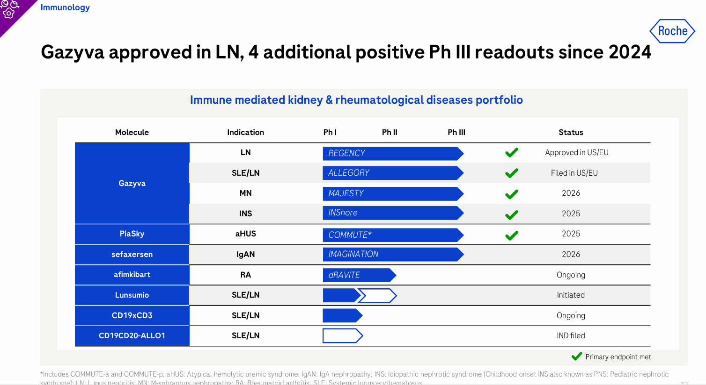
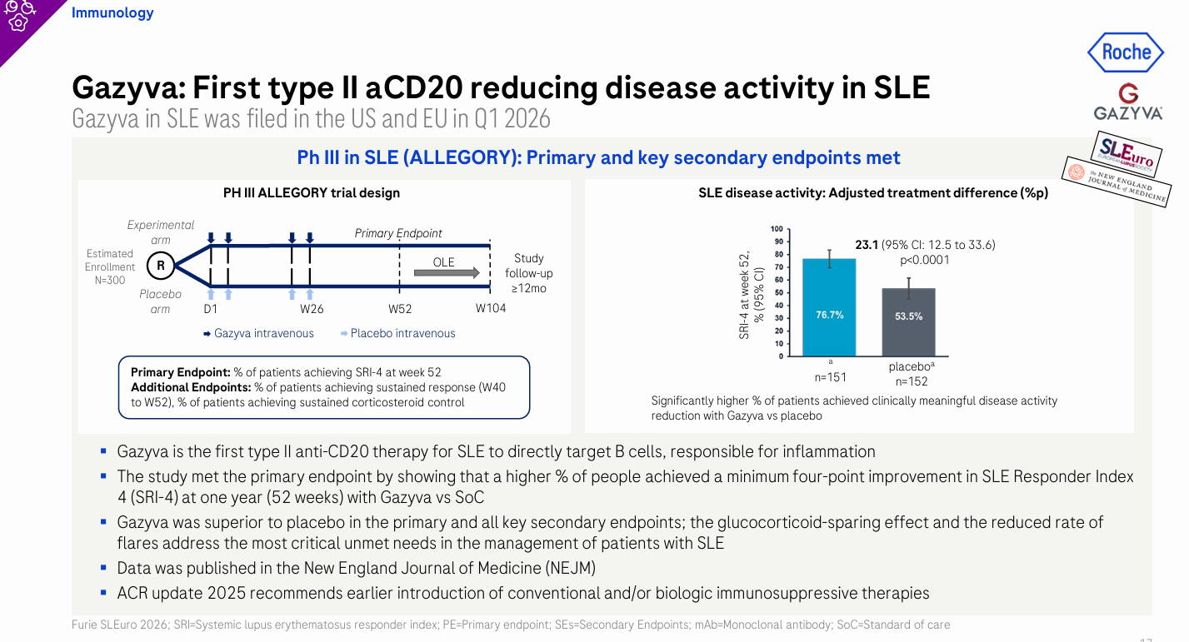

For questions, please reach out to:
 | Dermatology | Rheumatology | Gastroenterology
APEX (US/PCS) | Chanda Bhat | Bethany Christmann | Luke Versten
IMABI (International/ Affiliates) | Priti Anand | Irene Knorn | Priti Anand

Invite your colleagues to inVision | Manage Email Preferences | Unsubscribe

This document/email contains competitive intelligence collected via an approved competitive intelligence supplier working on behalf of AbbVie. We collect competitive intelligence consistent with industry standards and AbbVie policy. Not for field distribution. Please reach out to APEX/IMABI, Legal, or OEC teams with any questions.

